**Topics covered**

Visibility

Feedback

Constraint

Prototype

Storyboard

Card sort

Wizard of OZ

Rule of Thirds

LATCH

High fidelity/low fidelity prototype

10 heuristics-no need to memorize them, but need to understand

Conceptual model

User-centered design

Contextual inquiries

Heuristic evaluation

Information architecture

Tree testing

Sitemap

Conversion rate

**Sample questions:**

Multiple choice

Which of the following about open card sorting is correct

1. Participants are asked to organize topics from content within your website into groups that make sense to them and then name each group they created in a way that they feel accurately describes the content.
2. Participants are asked to sort topics from content within your website into pre-defined categories.
3. An open card sort allows you to really test out your categories labels to see if they are intuitive to your participants.
4. “Cards” should focus on the structure rather than the content of a Website.

True or False

1. In a tree testing, participants are required to organize cards into different categories, and give a name for each category.

Short answer question

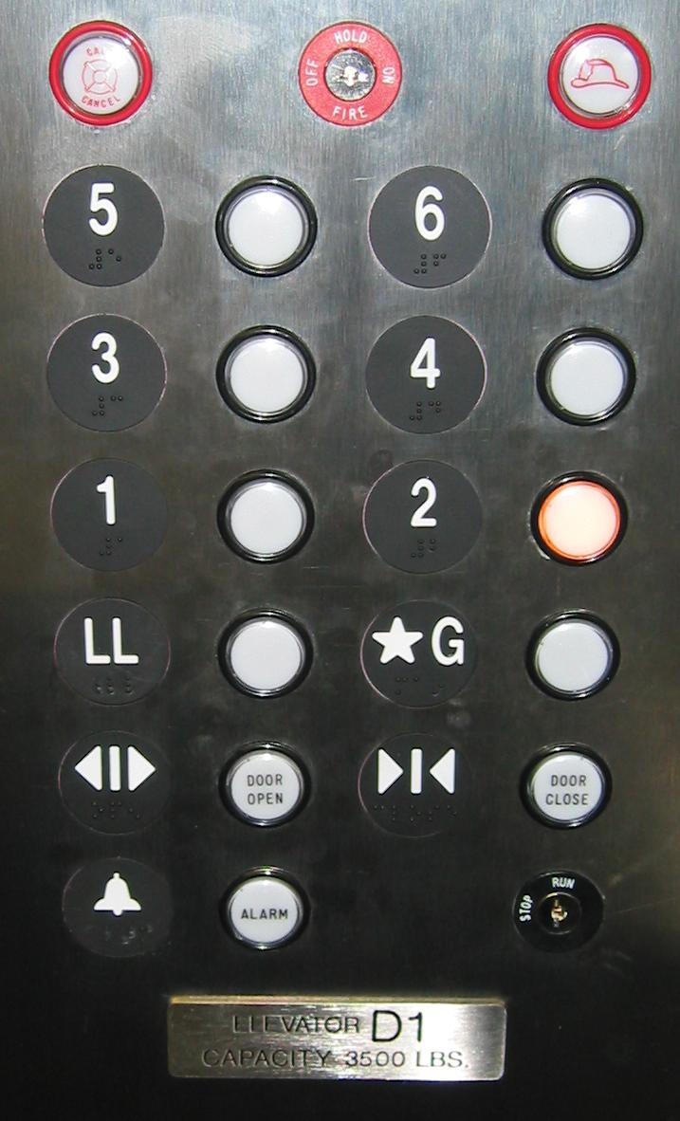Comparing the two designs of elevator buttons, which one do you think is a better design, and why?